1. We can take out a factor of 2 so that leaves . This cannot be reduced any further so the answer is ****
2. A 3, 4, 5 triangle is a right triangle with legs 3 and 4. If we do we get so the answer is 6
3. Since we start off with x pieces, after we give away half of the candy to the first student, we are left with pieces. After we give half of what we have left to the second student we are left with pieces. Since it states that at the end, we are left with 43 pieces, , x = 172
4. We just use order of operations to solve this problem, if we do everything if parentheses first, we are left with . Then if we do all the exponents, we are left with . We can do the bracket in the middle which is just 11 and then we can multiply to get which is equal to 48 which is our answer.
5. Since there is a of getting a head each time, there is a chance of getting five heads in a throw which is equal to 
6. The 21st prime number is 73
7. The formula for the surface area of a sphere is , if we set this equal to we get and so r = 3. The formula for the volume of a sphere is , and if we plug in r = 3 into this formula we get .  is our answer
8. If we square this equation, we get .Since the  we have  and so x = 12
9. We could use  but a faster method would be to use the fact that Pythagorean triple tend to be in this set . If we plug in n = 29 we get and so 421 is our answer.
10. If we set  and if we multiply S by 7, we get  . If we subtract 7S by S we get  which is an infinite geometric series with first term 1 and common ratio . If we use the formula  where a is the starting term and r is the common ratio, we get . This leads us to which is our answer.
11. The formula for the nth hexagonal number is , if we substitute 7 for n we get 
12. The formula for the sum of the interior angle of a n-gon is . If we replace n with 29, we get 
13. Since the unit's digit becomes 0 at , we can just multiply the tens digit by 6-10 to get our hundred's digit (multiplying the tens digit by 10 gives us the hundred's digit). At  our last two digits are 20, and if we multiply by 6 our tens digit is still 2. Multiply by 7, it becomes 4. Multiply by 8, it becomes 2. If we multiply it by 9, we get 8 as our tens digit. Finally, we multiply the 8 by 10 to get 80 and so 9 is our hundreds digit. You could also do  which isn't too bad.

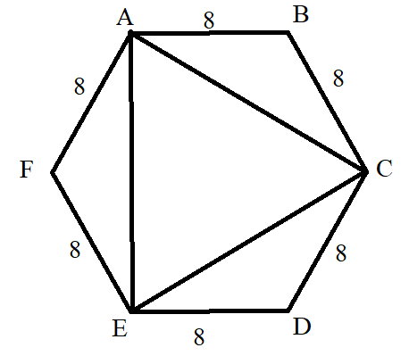Since the hexagon is deemed to be a regular hexagon, each angle is 120 degrees. Since .  would be congruent to the perimeter of triangle ACE. and so . The path Bryan would have to take is miles.

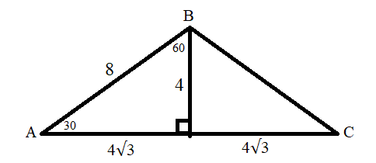

1. , if we multiply this by 22, we get 

